3. Mechanical
Halbach proof-of-principle magnets were constructed and tested to verify the ability of these magnet types to meet the CBETA technical and installation requirements as well as the magnetic field quality requirements discussed in the previous section. Another goal of the pre-production was to design and build a double cell assembly (8 magnets, 4 magnets/cell) that would match the requirements for a production cell assembly to be installed in CBETA.
The pre-production assembly incorporated the following features that will be used on the production magnets to meet these goals:
- For vacuum chamber installation and maintenance, the magnets were built with aluminum outer frames that are split on the vertical plane. The split allows installation of a complete and tested vacuum chamber assembly with beam position monitors installed and tested. The aluminum frames provide higher strength and low deflection when resisting the magnetic forces from the PMM blocks. The frames were also machined with tight tolerances to provide accurate positioning of the blocks.
- The aluminum frames are cross drilled with water passages for temperature stabilization of the permanent magnet material (PMM) in the magnet. Aluminum also provides excellent thermal conductivity for low temperature variation around the outer circumference of the PMM ring.
- To deal with the possible variation of the PMM field strength, the magnet assemblies were designed to be built with shims that were used to vary the inner radius of the PMM and therefore the strength of the magnet assembly.
- These are the first Halbach magnets built for CBETA that use epoxy to hold the PMM blocks in place especially when the magnets are split. Forces on the individual blocks could be up to 150 lbf and the stress on the epoxy as high as 100 psi.
Prior to manufacturing the aluminum frames, they were analyzed with the ANSYS finite element thermal and stress analysis program and their design modified and optimized to reduce stress and deflection. Shown below are analyses performed for deflection and stress distribution. All three magnet frame types were analyzed for stress, deflection, and temperature stability.
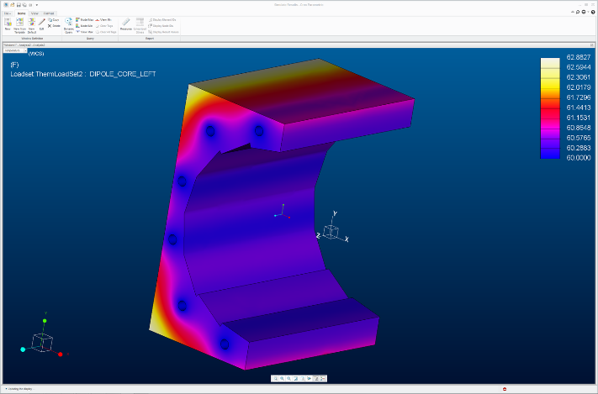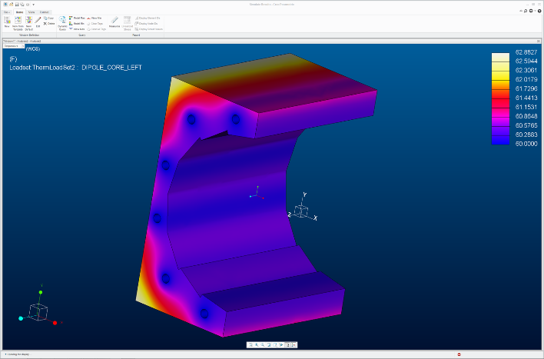
Tensile and shear bond strengths for epoxy are typical over 1000 psi. Analysis of the block to block forces of the PMM were completed. These resulted in forces on the aluminum frame and forces on the epoxy tasked with holding the blocks to each other and to the aluminum frame. These were used for the deflection analysis shown above and to verify that the stress on the epoxy was within its design values. Shown below is the analysis for the BD (dipole) Halbach magnets which have the highest force on individual end blocks – 343 N (77 lbf) per block. With a block surface area of 2.2 in^2, the tensile stress on the epoxy is less than 100 psi. Properly prepared surfaces and cured epoxy worked well on the pre-production magnets. Adhesion tests will be a requirement for the production magnets.
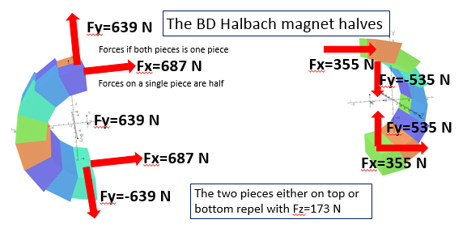
The magnet frames were manufactured with alignment dowels which worked repeatedly throughout the measurement process. The measurement results were consistent throughout the measurement and the tuning process. The image below shows the design model for the magnet assembly with assembly brackets and alignment dowls.
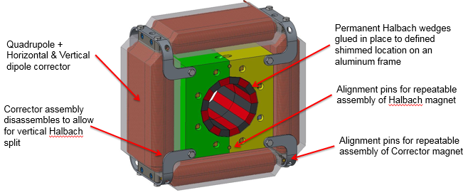

The girder for supporting the 8 FFAG magnets in a double cell assembly has been significantly simplified because the Halbach magnets are 1/10 the weight of the originally planned Hybrid (Steel/PMM) magnets. The magnets for the preproduction magnet assembly have been mounted on an accurately machined aluminum plate. The aluminum plate was accurate machined using a CNC water jet cutter which included access holes below for the water lines and to aid in the passive cooling of the correctors. Taped holes and smaller mounting holes can be located with a single CNC operation for the magnet mounting points.

- Alignment
As discussed in the Mechanical Section above, the Halbach magnet frames were accurately machined to provide accurate positioning of the PMM blocks and accurate alignment of the magnet halves. Accurate positioning of the magnet assemblies is achieved with multi-position jacking and alignment screws that can be locked into place after survey. The model and photo below show the kinematic mount for the magnets. A lesson learned during construction was to modify the bracket to provide more space for the vertical corrector coil.
